W1801R-How to change the SSID and wireless password?
Product line: wireless question category: wireless settings

1.Connect the router to your computer.
2. Open a browser or safari, then input 192.168.0.1 in the address bar, click Enter.
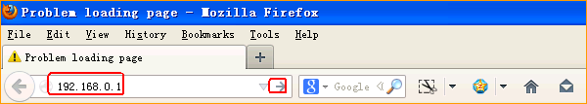
2.Input admin, admin, click Login.
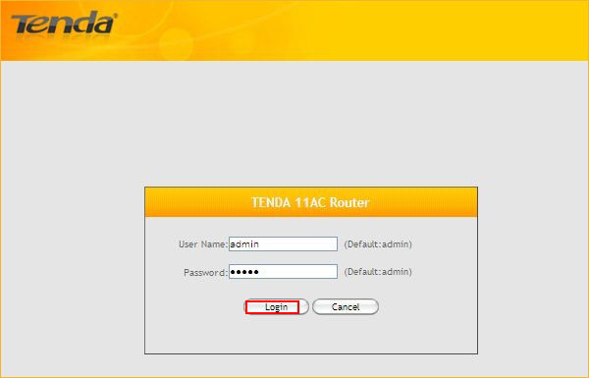

3.Click Advanced.

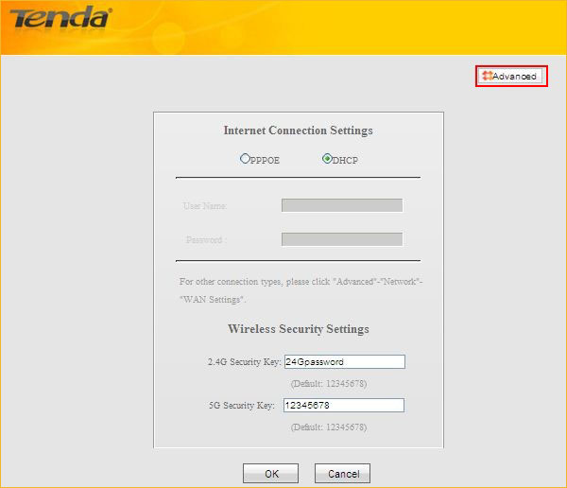

4.Click on Wireless, change the SSID(Wireless network name). The setting for 5G is the same.
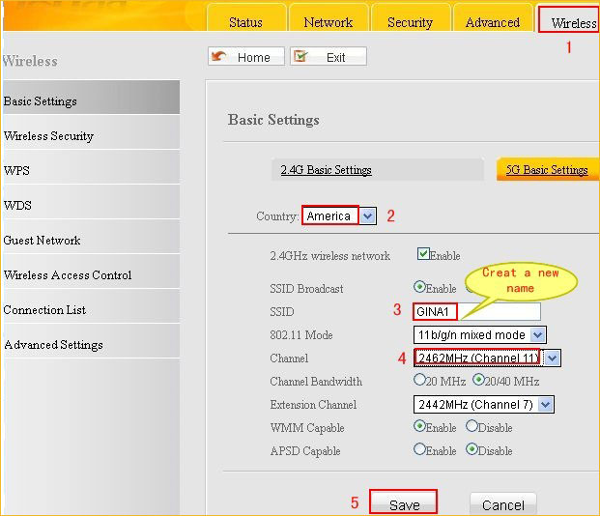

5. Click on Wireless Security

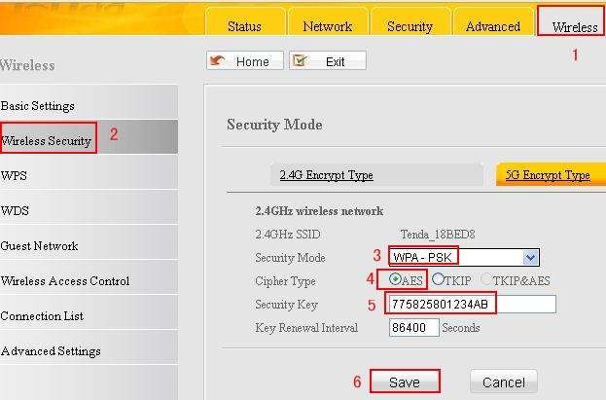

It’s the same for 5G.

